Push:

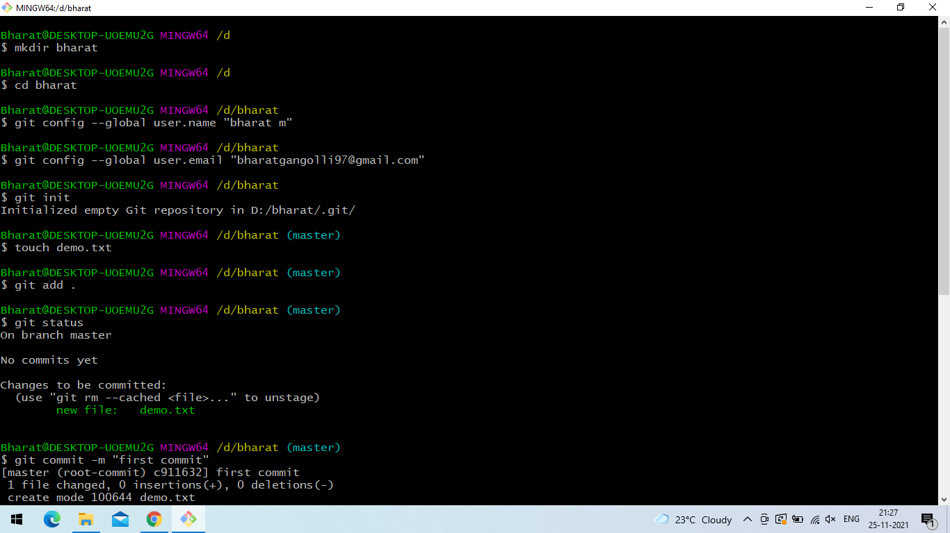

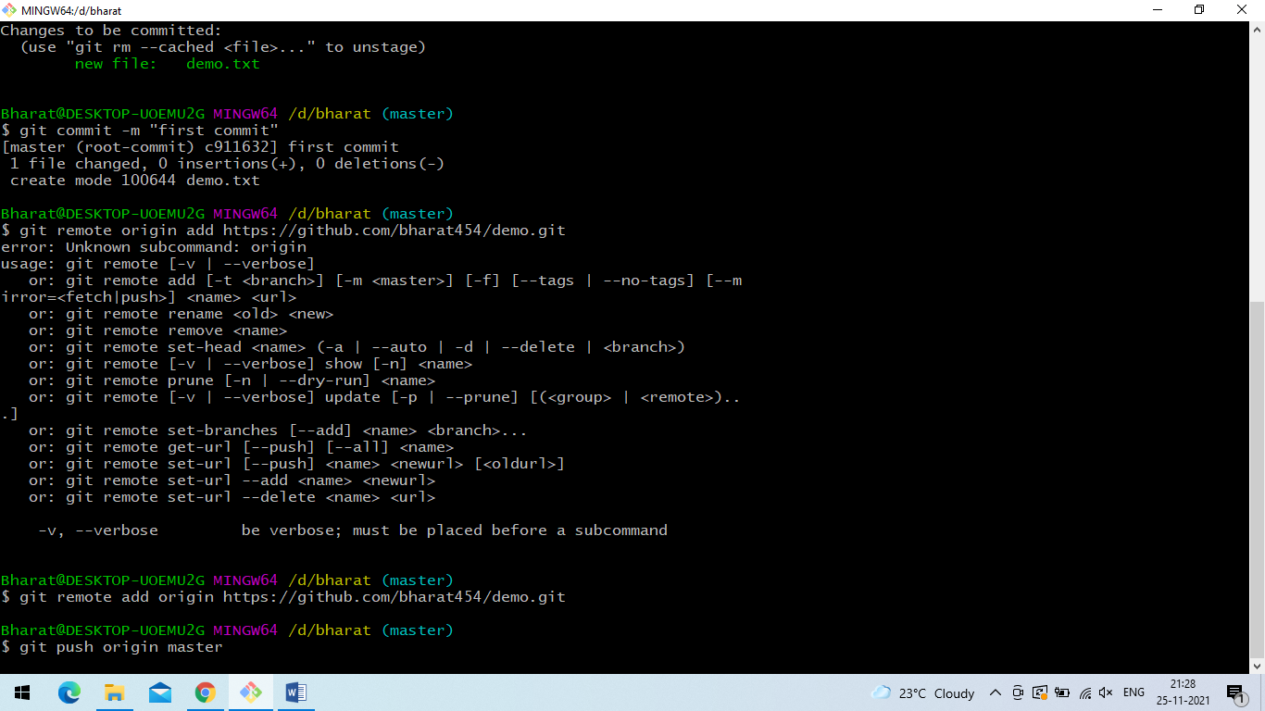

Pull

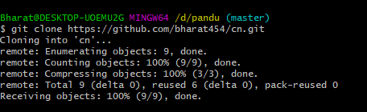

Fetch

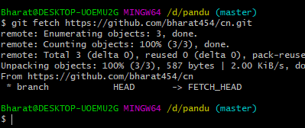

Branch create and delete

$ mkdir bharat

$ cd bharat

$ git config --global user.name "Bharat"

$ git config --global user.email "bharatgangolli97@gmail.com"

$ git init

$ touch demo1.txt

$ git add .

$ git commit -m "first commited"

$ git status

Bharat@DESKTOP-UOEMU2G MINGW64 /d/bharat (master)

$ git commit -m "first commited"

[master (root-commit) 06714b0] first commited

1 file changed, 0 insertions(+), 0 deletions(-)

create mode 100644 demo1.txt

Bharat@DESKTOP-UOEMU2G MINGW64 /d/bharat (master)

$ git status

On branch master

nothing to commit, working tree clean

Bharat@DESKTOP-UOEMU2G MINGW64 /d/bharat (master)

$ git checkout -b b1

Switched to a new branch 'b1'

Bharat@DESKTOP-UOEMU2G MINGW64 /d/bharat (b1)

$ touch demo3.txt

$ git add .

$ git commit -m "second commited"

$ git status

$ git checkout master

$ git merge b1

$ git branch -D b1

Deleted branch b1 (was aedbbc5).

Bharat@DESKTOP-UOEMU2G MINGW64 /d/bharat (master)

$ ls

demo1.txt demo3.txt